UVM final project solution

Verification plan
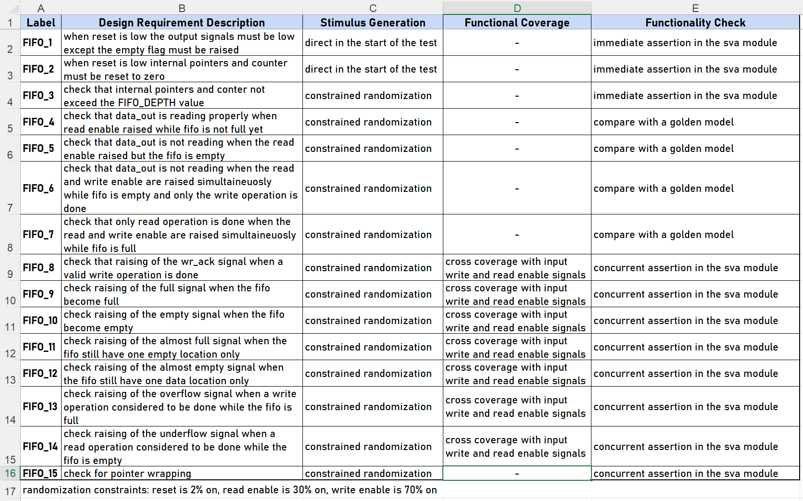

UVM testbench structure
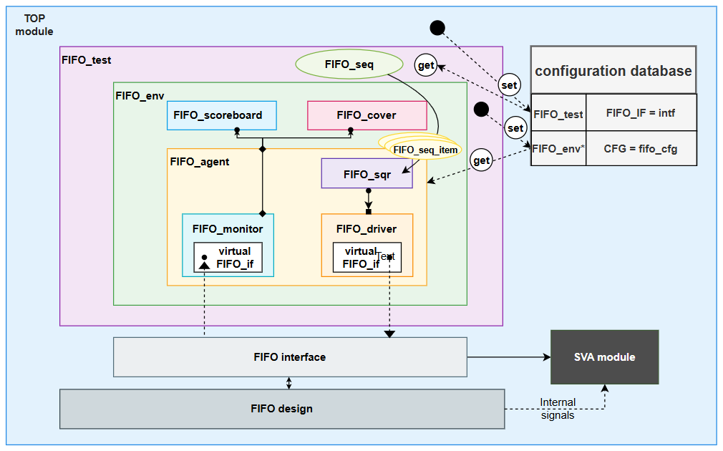

In detail discerption about how the testbench works

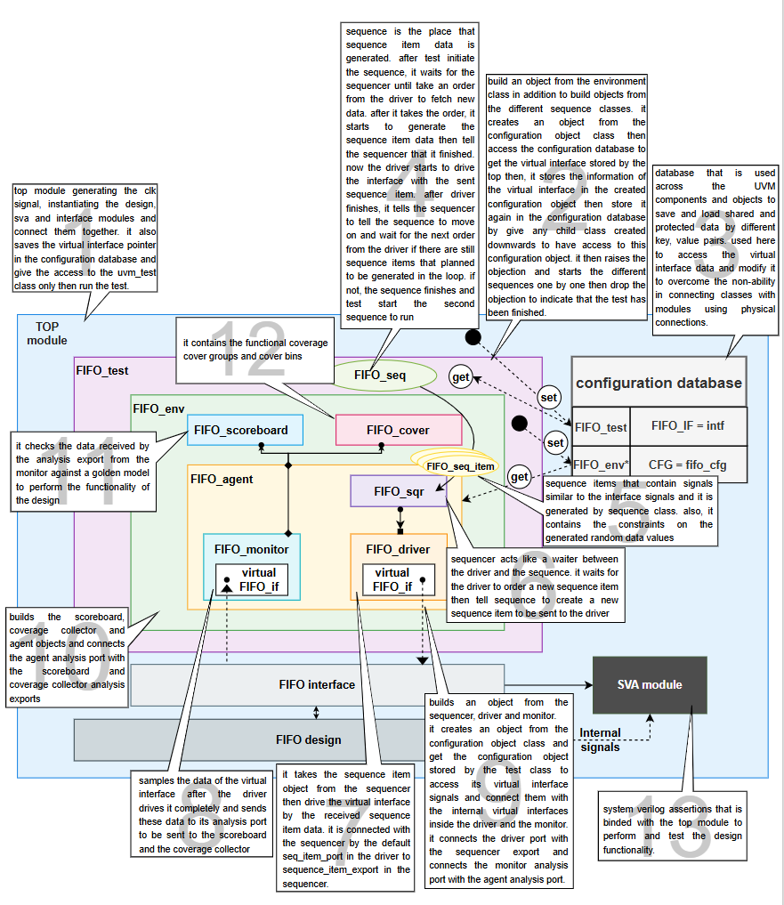

Bug report (same as sv final project)

Output data

observation
When the FIFO is full and the input write enable and read enable signals are both high the output becomes different from the expected output.

Cause
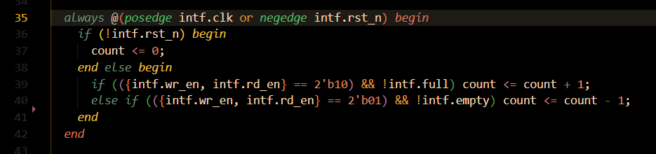
This scenario is not considered when updating the FIFO's internal counter. When both write and read enables are high, the counter value remains unchanged, rather than decrementing by one—even though only a read operation should be effectively counted in that case. Similarly, when the FIFO is empty and both read and write enables are high, the counter value remains zero instead of incrementing by one, even though only a write operation should be considered in this situation.

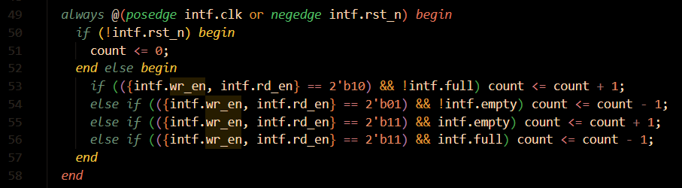
FIX

Under flow signal

Observation
Under flow signal is driven computationally not sequentially

Error code
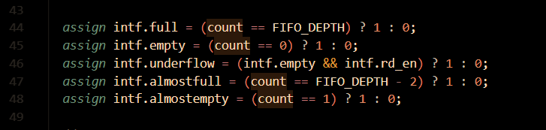

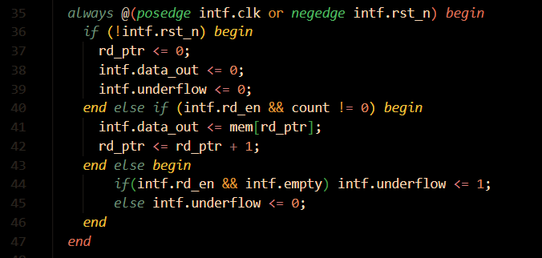
FIX

Almost full signal

Observation
It was found that the almost full signal is asserted one entry earlier than expected. When the FIFO still has two available slots, the signal is raised instead of waiting until only one slot remains before becoming full.

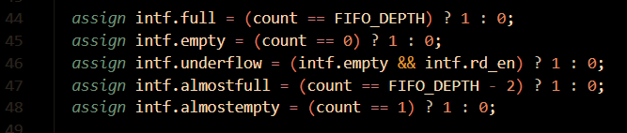
Error in the code

FIX
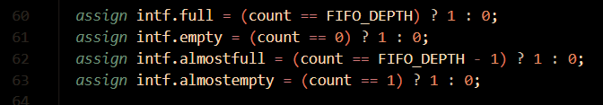

Top resetting

Observation
The registered outputs are not reset when the reset signal is asserted, it remains unchanged.

Fix
Reset output registered signals which are data_out, wr_ack, overflow, underflow.

Extra detected bugs according to adding more assertions test cases (not included in the previous sv final project)

Overflow and underflow signals (observation)
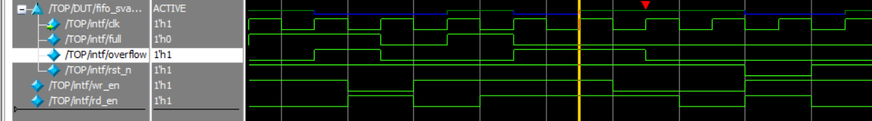
Look at the scenario in the following waveform and code snippet

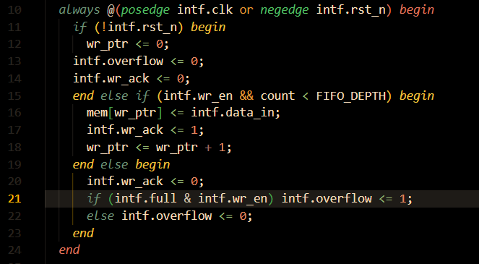

In this scenario, when the FIFO is full and wr_en = 1, the overflow signal is asserted. However, if wr_en remains high and rd_en is asserted, a read operation occurs while the write operation is ignored, causing the FIFO to no longer be full. Therefore, the overflow signal should be deasserted, but instead it remains asserted until wr_en goes low.

Fix
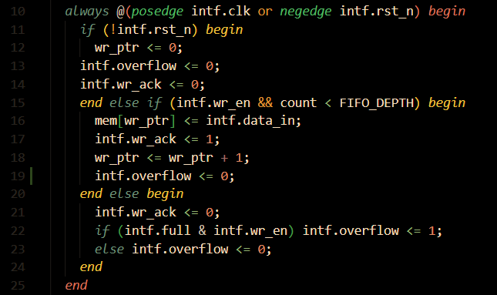
Add intf.overflow<=0 in the second branch to make sure that it will be zero at any valid write operation.

The same issue happened in the underflow signal, and we fixed it with the same method.
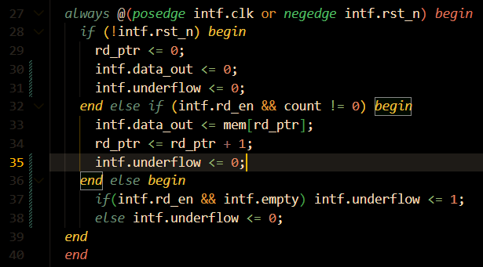

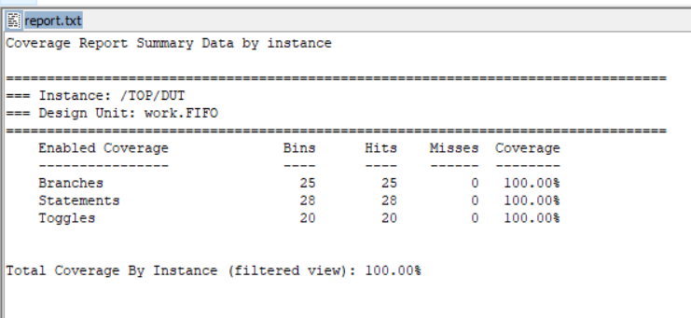
Code coverage report

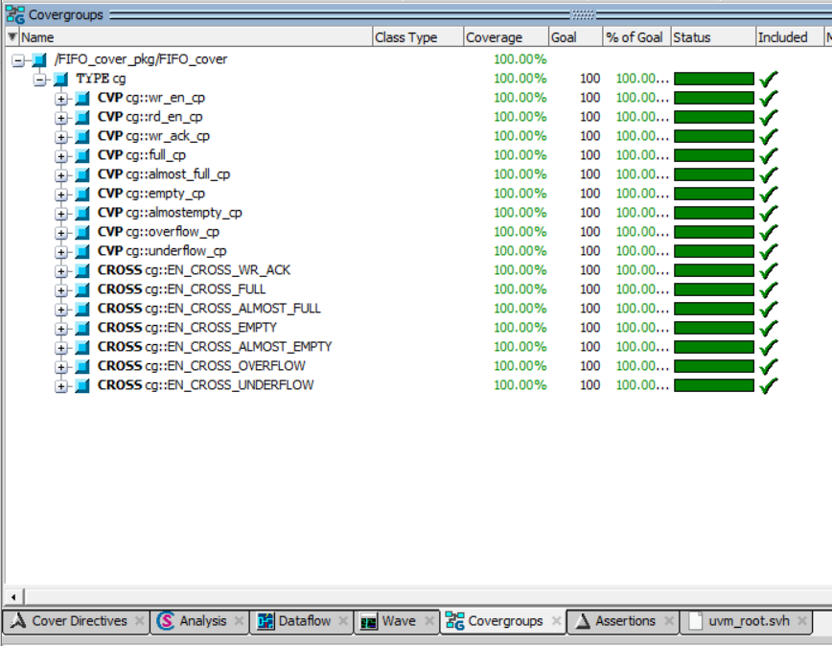
Functional coverage

Assertion results and coverage
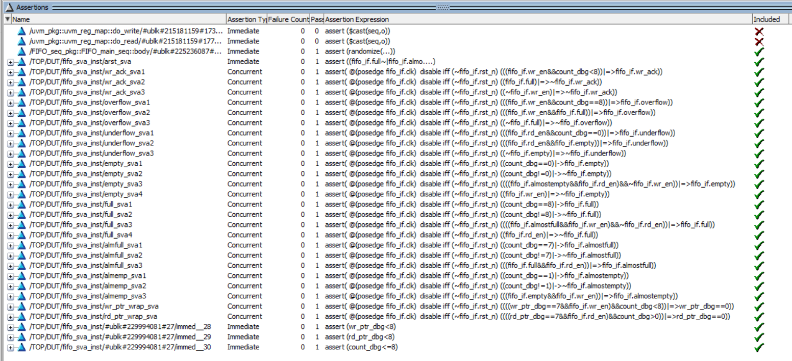

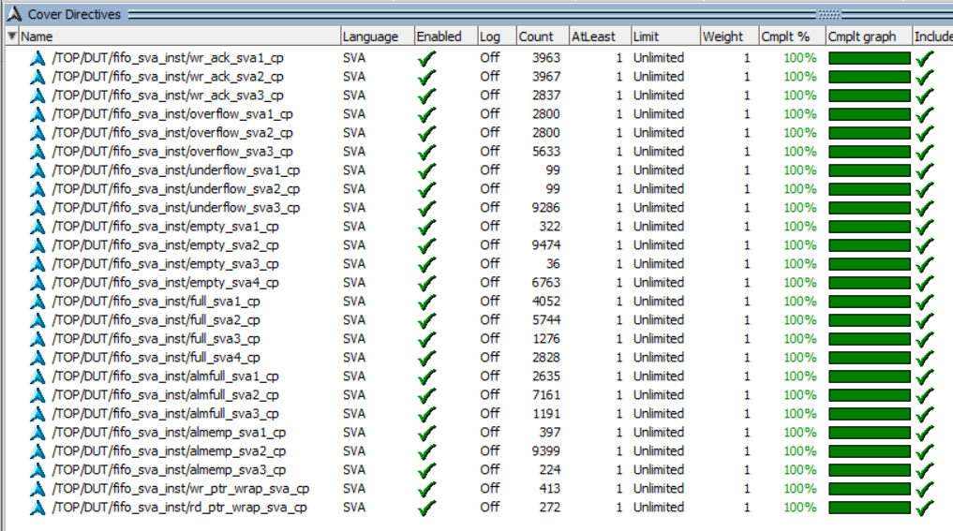

Sequences in waveform

Reset sequence
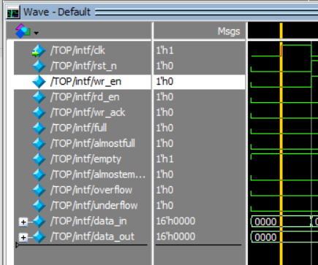

Main sequence
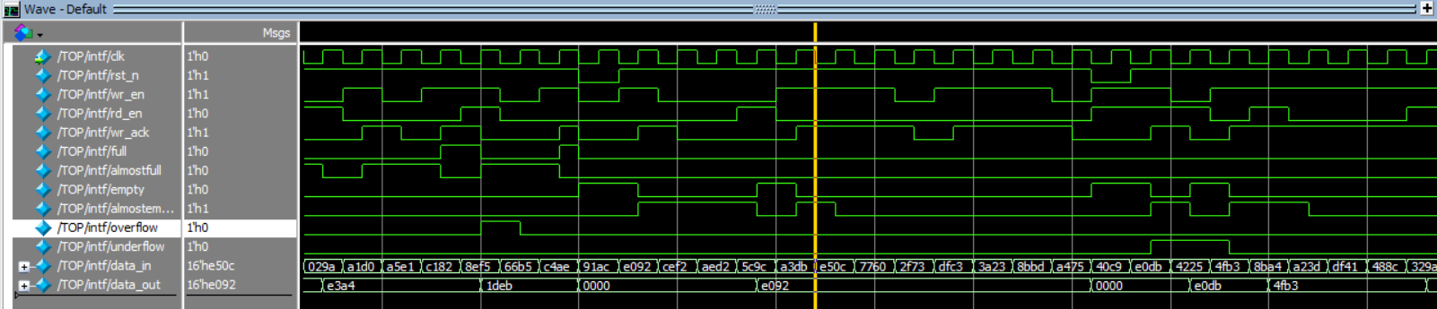

Assertion table
Feature | Assertion | type
When reset is asserted, all registered outputs are reset to zero asynchronously | Direct assertion
Whenever wr_en is asserted and internal counter value is less than FIFO_DEPTH means that FIFO is not full, wr_ack is = 1 | @ (posedge fifo_if.clk) fifo_if.wr_en && count_dbg < FIFO_DEPTH |=> fifo_if.wr_ack;
Whenever FIFO is full, wr_ack is always = 0 | @ (posedge fifo_if.clk) fifo_if.full |=> !fifo_if.wr_ack;
Whenever wr_en is 0 the wr_ack is also 0 | @(posedge fifo_if.clk) !fifo_if.wr_en |=> !fifo_if.wr_ack;
Whenever wr_en is asserted and the internal counter is = FIFO_DEPTH means that FIFO is full, overflow is = 1 | @(posedge fifo_if.clk) fifo_if.wr_en && count_dbg == FIFO_DEPTH |=> fifo_if.overflow;
Whenever wr_en is asserted while FIFO is full, overflow is = 1 | @(posedge fifo_if.clk) fifo_if.wr_en && fifo_if.full |=> fifo_if.overflow;
Whenever FIFO is not full, overflow is = 0 | @(posedge fifo_if.clk) !fifo_if.full |=> !fifo_if.overflow;
Whenever internal counter is = 0, the empty signal is = 1 | @(posedge fifo_if.clk) count_dbg == 0 |-> fifo_if.empty;
Whenever internal counter is not = 0, the empty signal is = 0. | @(posedge fifo_if.clk) count_dbg != 0 |-> !fifo_if.empty;
When the almostempty is asserted and a read operation is required without a write operation then empty signal will be = 1 | @(posedge fifo_if.clk) fifo_if.almostempty && fifo_if.rd_en && !fifo_if.wr_en |=> fifo_if.empty;
Whenever wr_en is asserted, empty signal must = 0 | @(posedge fifo_if.clk) fifo_if.wr_en |=> !fifo_if.empty;
Whenever internal counter is = FIFO_DEPTH, the full signal is = 1 | @(posedge fifo_if.clk) count_dbg == FIFO_DEPTH |-> fifo_if.full;
Whenever internal counter is not = FIFO_DEPTH, the full signal is = 0. | @(posedge fifo_if.clk) count_dbg != FIFO_DEPTH |-> !fifo_if.full;
When the almostfull is asserted and a write operation is required without a read operation then full signal will be = 1 | @(posedge fifo_if.clk) fifo_if.almostfull && fifo_if.wr_en && !fifo_if.rd_en |=> fifo_if.full;
Whenever rd_en is asserted, full signal must = 0 | @(posedge fifo_if.clk) fifo_if.rd_en |=> !fifo_if.full;
Whenever internal counter = FIFO_DEPTH – 1, the almostfull signal is asserted | @(posedge fifo_if.clk) count_dbg == FIFO_DEPTH - 1 |-> fifo_if.almostfull;
When internal counter != FIFO_DEPTH-1, the almostfull signal is deasserted | @(posedge fifo_if.clk) count_dbg != FIFO_DEPTH - 1 |-> !fifo_if.almostfull;
When the FIFO is full and rd_en is asserted while wr_en is deasserted, the almostfull signal will assert | @(posedge fifo_if.clk) fifo_if.full && fifo_if.rd_en |=> fifo_if.almostfull;
Whenever internal counter = 1, the almostempty signal is asserted | @(posedge fifo_if.clk) count_dbg == 1 |-> fifo_if.almostempty;
When internal counter != 1, the almostempty signal is deasserted | @(posedge fifo_if.clk) count_dbg != 1 |-> !fifo_if.almostempty;
When the FIFO is empty and wr_en is asserted while rd_en is deasserted, the almostempty signal will assert | @(posedge fifo_if.clk) fifo_if.empty && fifo_if.wr_en |=> fifo_if.almostempty;
When wr_ptr reaches maximum value, check wrapping around in case wr_en is asserted while the internal counter is not = FIFO_DEPTH | @(posedge fifo_if.clk) wr_ptr_dbg == 7 && fifo_if.wr_en && count_dbg < FIFO_DEPTH |=> wr_ptr_dbg == 0;
When rd_ptr reaches maximum value, check wrapping around in case rd_en is asserted while the internal counter is not = 0 | @(posedge fifo_if.clk) rd_ptr_dbg == 7 && fifo_if.rd_en && count_dbg > 0 |=> rd_ptr_dbg == 0;

